CONTENTS

CONTENTS 2
1. ABSTRACT 5
2.INTRODUCTION 6
3. LITERATURE REVIEW 7
4. PROBLEM DESCRIPTION 8
5. DATA SELECTION AND PREPARATION 8
5.1 Dataset Description and Source 8
5.2 Data Preprocessing 11
5.3 Data Normalization. 12
5.4 Dataset Augmentation 12
6. Model Architecture 14
7. Model Implementation 15
7.1 Data Pipeline 15
7.2 Model Instantiation 15
7.3 Training Loop 16
7.4 Evaluation 17
8. Model Evaluation 19
8.1 Comparison with State of the Art Models 21
9 .Conclusions 22
10. REFERENCES 23
11. BIBLIOGRAPHY 24
12.APPENDIX 25

1. ABSTRACT

Precise demarcation of pathological areas in medical images is a critical requirement for accurate diagnosis and treatment planning. Manual segmentation by medical professionals is a time consuming error prone and subjective process often affected by inter-observer variability. This research work proposes an automated medical image segmentation system based on deep learning to detect breast tumors in ultrasound images. The proposed work utilized the Breast Ultrasound Images (BUSI) database which included labeled images of benign and malignant tumors. The proposed system utilized a convolutional neural network based on the U Net model because of its excellent performance in biomedical image segmentation.
The proposed system was trained to learn pixel level classification and was tested using Dice coefficient Intersection over Union (IoU) and precision measures. The experimental outcome confirmed the high accuracy of segmentation proving that the proposed system effectively segmented the tumor area despite the presence of noise and low contrast in ultrasound images. The proposed system emphasizes the effectiveness of automated segmentation in supporting radiologists to improve diagnostic accuracy reduce workload and enable faster decision making.

2.INTRODUCTION

Medical imaging is an important tool in the diagnosis and treatment of diseases as well as monitoring the health of patients. Medical imaging techniques such as Magnetic Resonance Imaging (MRI) scans Computed Tomography (CT) scans and Ultrasound imaging allow doctors to see inside the body without invading it. However one of the most essential steps in medical image analysis is segmentation which is the process of marking and extracting medically significant body regions such as organs tissues or tumors.
Manual segmentation by radiologists is the conventional method of segmenting images. While this method is efficient there are several drawbacks to manual image annotation. The process is time consuming especially when dealing with large image datasets and the results may vary from one expert to another depending on the subjective interpretation of the images. Moreover in situations where the images are complex such as irregular tumor shapes or noisy ultrasound images accurate segmentation is difficult.
However recent breakthroughs in deep learning and computer vision have offered effective solutions to these problems. Convolutional Neural Networks (CNNs) especially encoder decoder networks allow for pixel wise classification with minimal human supervision. Of these U-Net has emerged as a popular choice for biomedical image segmentation because of its capability to model contextual as well as spatial information using skip connections.
The proposed project aims to develop an automated segmentation model that can effectively identify tumor areas in ultrasound medical images. Through the use of deep learning based image segmentation this research study hopes to improve the accuracy of diagnoses and minimize the problem of manual annotation.

3. LITERATURE REVIEW

Medical image segmentation has seen a dramatic change with the advent of deep learning algorithms. Traditional computer vision algorithms like thresholding region growing and edge detection were used in earlier works. Although computationally efficient these algorithms were prone to noise intensity variations and complex anatomical structures which are quite common in medical images.
The advent of Convolutional Neural Networks has transformed the way we perform segmentation tasks. They have the capability to automatically extract features. Among the most popular architectures is the U-Net which was designed specifically for the task of biomedical image segmentation. Its encoder decoder architecture is capable of learning hierarchical features while skip connections ensure that spatial details are preserved even when the training dataset is small.
Later developments have given rise to models such as DeepLabV3 which uses atrous convolution to learn multi scale contextual features and nnU-Net which is an adaptive model that can automatically adjust preprocessing and training parameters depending on the characteristics of the dataset. These models have shown state of the art performance on a wide range of modalities such as CT, MRI and ultrasound scans.
However despite these improvements some challenges still exist. For instance many deep learning architectures are computationally expensive and require large amounts of annotated data. Moreover there may be a loss of performance in noisy imaging modalities like ultrasound due to speckle artifacts and low contrast. Additionally real time clinical applications are still not possible due to latency in inference and generalization problems across various imaging devices.
This paper fills these research gaps by designing an efficient segmentation network that can learn robust boundaries from noisy ultrasound images while having feasible computational requirements for clinical assistance systems.

4. PROBLEM DESCRIPTION

Precise segmentation of the tumor area in medical images is a critical requirement for early disease diagnosis and treatment planning. Nevertheless manual image segmentation by medical professionals is a time consuming process and prone to human error especially when handling complex tumor shapes and poor image quality conditions. In ultrasound imaging the presence of speckle noise and indistinct boundaries further hinders the accurate delineation of pathological regions.
The practical problem addressed in this research project is the creation of an automated system that can efficiently detect and segment the tumor area from ultrasound images with high accuracy. The system should decrease reliance on manual image annotation while maintaining acceptable accuracy levels.
The main objective of this research project is to develop a deep learning segmentation model that can learn pixel level classification of tumor and non tumor areas. The developed model should be able to effectively detect tumor boundaries generalize well across different images and produce consistent results. Finally the proposed solution is expected to benefit medical professionals by enhancing diagnostic efficiency and reproducibility.

5. DATA SELECTION AND PREPARATION

5.1 Dataset Description and Source
The Breast Ultrasound Images (BUSI) dataset was employed for the development and testing of the proposed medical image segmentation system. The BUSI dataset is comprised of breast ultrasound images which are grouped into three clinical classes: normal tissue, benign tumors and malignant tumors. Each ultrasound image is paired with a ground truth segmentation mask which is manually labeled by medical experts. The segmentation mask is labeled at the pixel level where the tumor area is marked as foreground and the background is marked as tissue. This labeling scheme enables the formulation of the segmentation problem as a supervised semantic segmentation problem.
The dataset was manually downloaded and saved to Google Drive to facilitate repeated access during experimentation. Inside the Google Colab environment, Google Drive was mounted to facilitate the retrieval of the dataset. After mounting the storage device the compressed file of the dataset was unzipped into the working directory. The original dataset organization included three folders which corresponded to the three clinical classes of the dataset (benign, malignant and normal). Screenshots are provided to verify the successful mounting of storage devices and the unzipping of the dataset.
For the dataset to be used for training the model images and their masks were split into separate directories. Every image file has a corresponding mask named by the “mask” suffix in the file name. A script was developed to automatically identify mask files and move them into a mask directory while moving original images into an image directory. This made the dataset easier to load and ensured a one to one correspondence between images and ground truth annotations. The total number of images and masks was checked after splitting to ensure data integrity as shown in Fig 1.
To ensure that the model could be evaluated for its performance the dataset was split into a training and validation set with an 80:20 split ratio. A random seed was used in the splitting process to ensure that the same images were used in both sets every time the process was repeated. The training set was used for training the model while the validation set was used only for evaluating the model’s performance as shown in Fig 2.
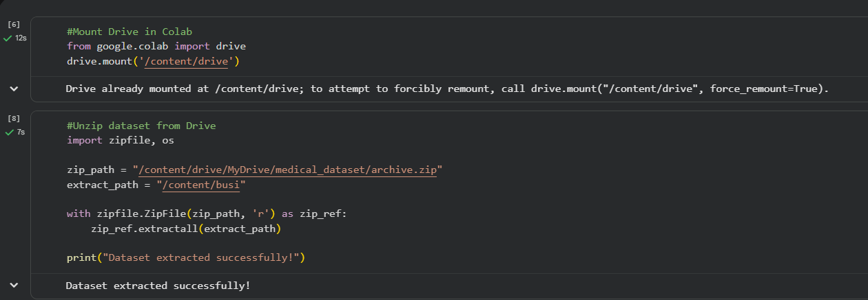
Fig 1
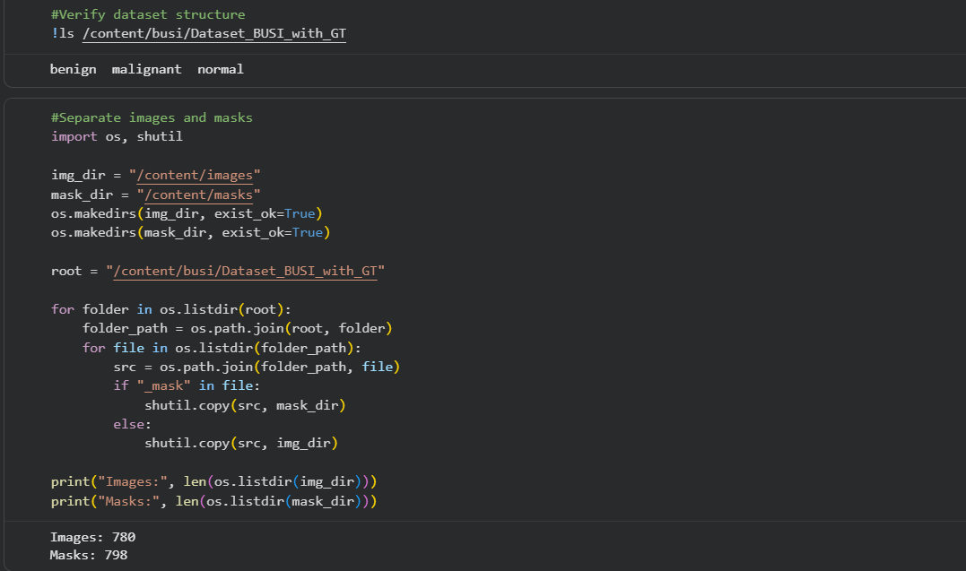
Fig 2
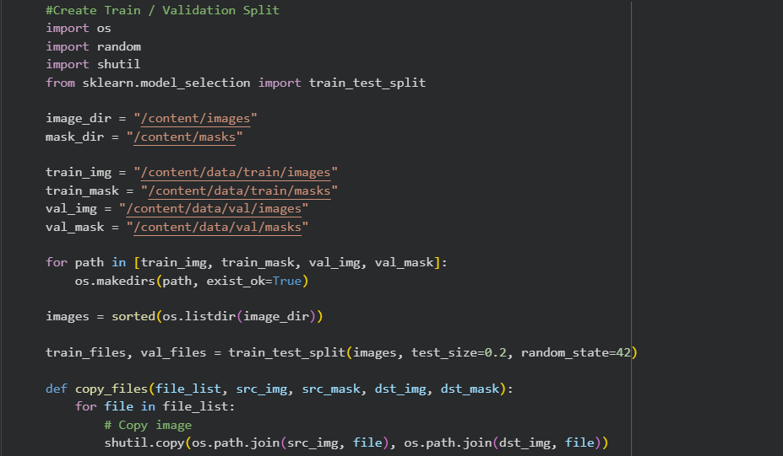
Fig 3
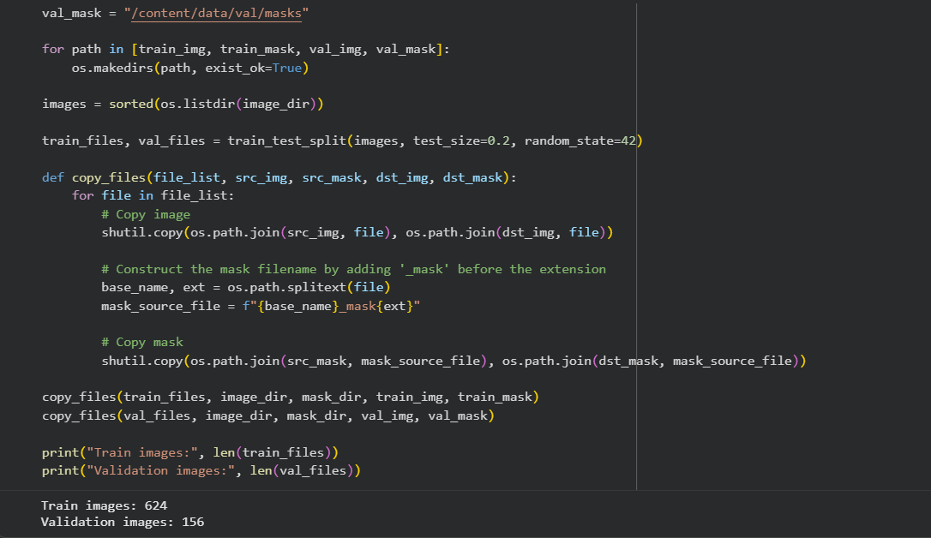
Fig 4

5.2 Data Preprocessing
In Fig 5 Before training the model some preprocessing steps were carried out to ensure consistency and stability during the training process. Medical images tend to have varying resolutions based on the imaging device used. So all the images and masks were made the size which is 256 by 256 pixels. This makes it easier to work with the images. We can still see the details we need to find the edge of the tumor. The images and masks are now all the size which is 256 by 256 pixels and that is good for computing. We can see the details of the tumor boundary in the images and masks because they are 256 by 256 pixels
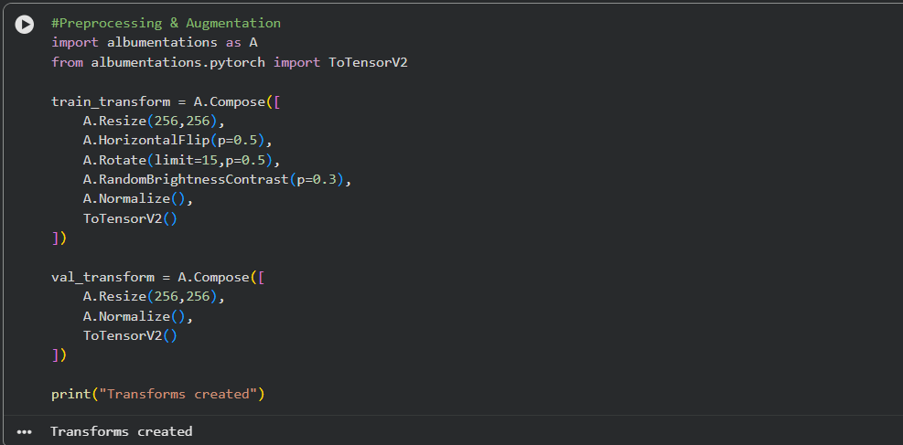
Fig 5

5.3 Data Normalization.
Intensity normalization was also done on the images. The pixel values in ultrasound images are quite different from one image to another due to the settings of the ultrasound device and the tissue density. If intensity normalization is not done the neural network may learn the intensity patterns of the device rather than the anatomical patterns as per Fig 6 .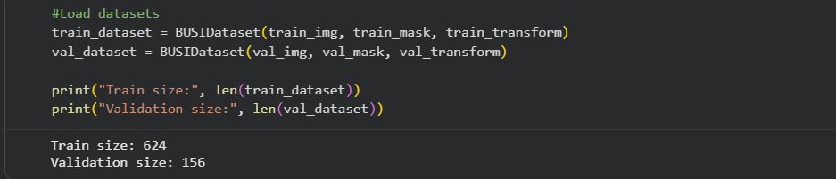
Fig 6

5.4 Dataset Augmentation
In Fig 7 data augmentation methods were employed to enhance the generalization capability of the model. In the case of medical image datasets it is challenging to obtain a substantial number of labeled samples as the labeling process involves domain expertise. However to overcome this drawback artificial variability was added to the training data using augmentation techniques. The augmentation techniques used were horizontal flipping ,rotation and brightness and contrast changes. Horizontal flipping simulates the variability of probe orientation, rotation simulates minor variations in patient placement and brightness changes simulate variations in the settings of the imaging equipment.
To enable reproducibility and fair assessment of the model the dataset was split into training and validation subsets with an 80:20 split ratio. A constant random seed was employed during the splitting procedure to ensure that the same images are allocated to both subsets in different runs. The training subset was utilized for training the model and the validation subset was used only for evaluation purposes. No augmentation was performed on the validation subset to obtain a fair estimate of the model's performance on real world images.
Finally the binary masks were transformed into a tensor representation that is compatible with the deep learning model. Each pixel was labeled as either foreground (tumor) or background class. This representation enables the segmentation problem to be framed as a pixel wise classification problem where the network predicts the probability of each pixel belonging to the tumor class.
The dataset was prepared for the deep learning based medical image segmentation through the above preprocessing and preparation steps. The preparation stage is very important to ensure that the model learns meaningful features and not artifacts of the imaging conditions.
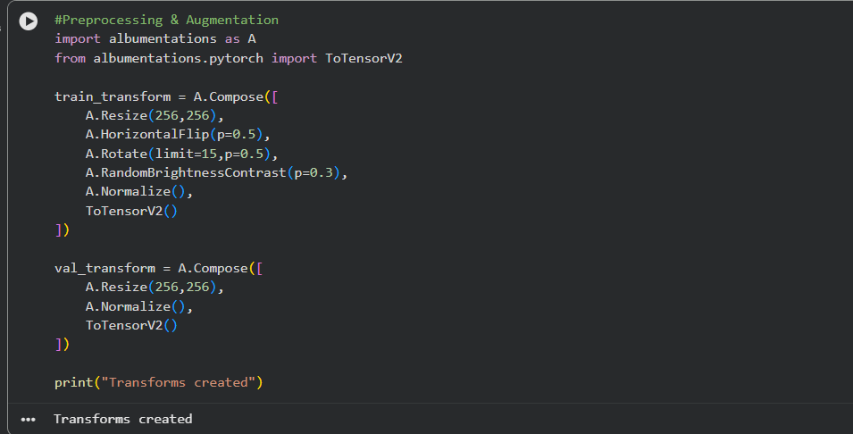
Fig 7
Dataset used Link: Breast Ultrasound Images Dataset

6. Model Architecture

In this research a deep learning model for semantic segmentation using the U-Net architecture was used. U-Net is a type of convolutional neural network that is particularly suited for biomedical image segmentation tasks. It has been widely used because of its excellent performance even when the size of the medical image dataset is small. U-Net is very useful in medical imaging tasks because it has the ability to understand the context of the image at the same time as it has the capability to locate it in space which is very important in identifying irregular boundaries of tumors.
The network used in this project is an encoder decoder network. The encoder is the feature extractor which reduces the spatial dimensions of the image while increasing the depth of the features. In this project, the encoder was replaced with a ResNet34 model that was pretrained on the ImageNet dataset. This is because medical image datasets are generally much smaller than natural image datasets. As such the pretraining of the weights of the network is very important because it enables the network to learn general features of images such as edges shapes and textures before learning the specific features of tumors.
The decoder uses up sampling to restore the segmentation map from feature maps to the original image size. Skip connections connect corresponding layers of the encoder and decoder enabling the recovery of fine spatial details lost through down sampling. This facilitates the detection of boundaries in low contrast ultrasound images where tumor boundaries are not easily visible.
The network takes a three channel input image and generates a one channel probability map indicating the presence of a tumor at each pixel. The sigmoid activation function is used to transform the output into pixel probabilities ranging from 0 to 1. A threshold is used to obtain a binary segmentation map during testing.
The U-Net architecture was chosen for three primary reasons(Ronneberger, Fischer and Brox, 2015). Firstly, the architecture shows a high level of segmentation accuracy for medical imaging tasks because of its capacity to integrate global context information with local details. Secondly the architecture is computationally efficient compared to other deep segmentation architectures like DeepLabV3 which makes it ideal to run in resource constrained settings like Google Colab. Thirdly the architecture is robust when trained on a relatively small dataset which is a common scenario in medical imaging.
In conclusion the balance between performance and efficiency offered by the U-Net architecture and the pretrained ResNet34 encoder makes it ideal for ultrasound tumor segmentation as shown in Fig 8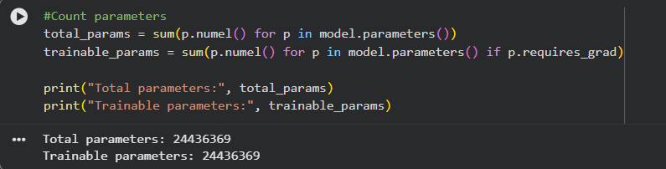
Fig 8

7. Model Implementation

The proposed segmentation algorithm was developed using Python with the PyTorch deep learning library in a Google Colab environment. The code was structured as a pipeline consisting of (1) data loading and preprocessing, (2) model definition, (3) training and (4) evaluation and visualization.

7.1 Data Pipeline
Organized images and masks were stored in separate directories. A PyTorch Dataset class was defined to handle: image and mask file reading image conversion to RGB mask conversion to binary (tumor = 1, background = 0), data preprocessing and augmentation transformations and tensor output for batching.
Data augmentation (horizontal flipping, small rotations, brightness and contrast changes) was performed only on the training data to enhance generalization capabilities while the validation data underwent deterministic resizing and normalization to provide an unbiased assessment. A DataLoader was utilized to batch samples for efficient feeding into the model with shuffling enabled for the training data.

7.2 Model Instantiation
In Fig 9, a U-Net model was applied for segmentation because of its excellent performance in biomedical applications. To enhance feature learning and facilitate faster convergence the encoder part of the U-Net was replaced by a ResNet34 model pretrained on the ImageNet dataset (transfer learning). The network accepts 3 channel inputs and generates a single channel binary mask output indicating the tumor area.
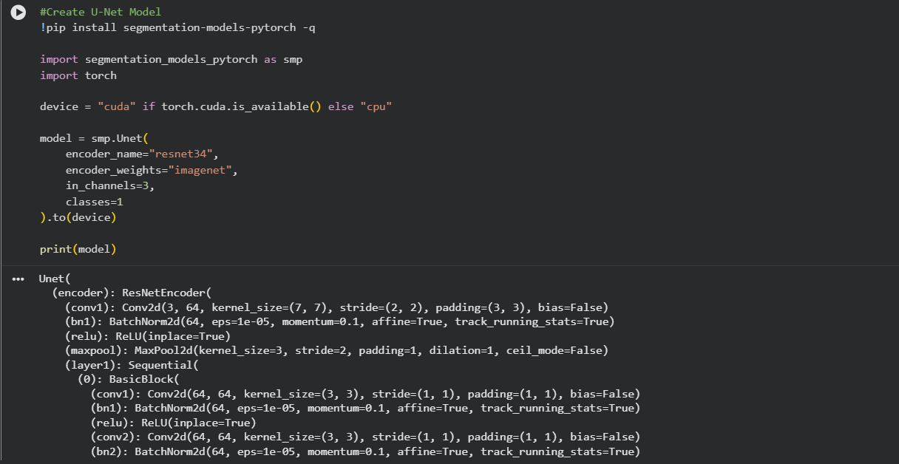
Fig 9

7.3 Training Loop
The supervised learning process was applied for training involving the forward pass, loss calculation backpropagation and update of parameters. The Adam optimizer was employed with a small learning rate for ensuring stable convergence. Since the tumor pixels are sparsely distributed compared to the background pixels the Dice Loss function was chosen as the main loss function because it maximizes the overlap between the predicted segmentation and the ground truth.
The training process was tracked using the loss values at each epoch and the screenshots of the training process were taken as proof of correct implementation as shown in Fig 10.
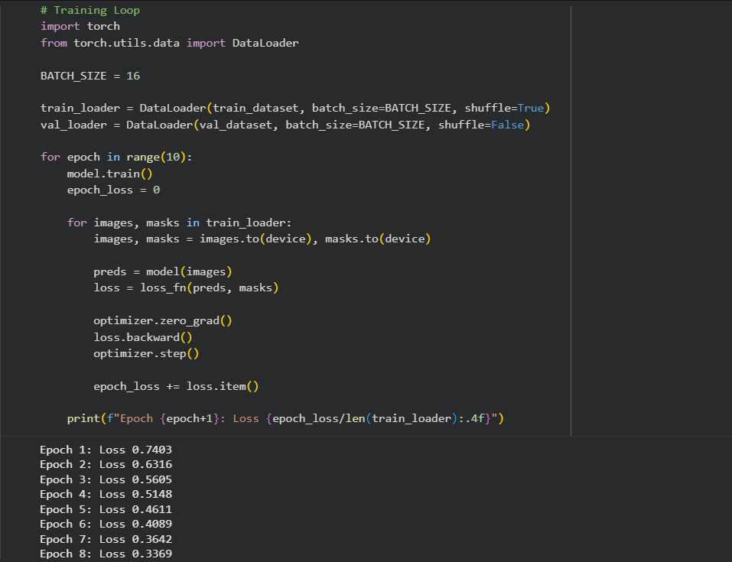
Fig 10

7.4 Evaluation
The performance of the model was evaluated using both quantitative and qualitative methods. Using the quantitative method the Dice coefficient and IoU were calculated on the validation set after thresholding the probability maps into binary masks. Using the qualitative method the predicted masks were displayed together with the ground truth masks to ensure the quality of the boundaries and the typical failure cases due to ultrasound noise or low contrast boundaries of lesions. This was done through the visualization of the output which was included in the report as required evidence as per Fig 11.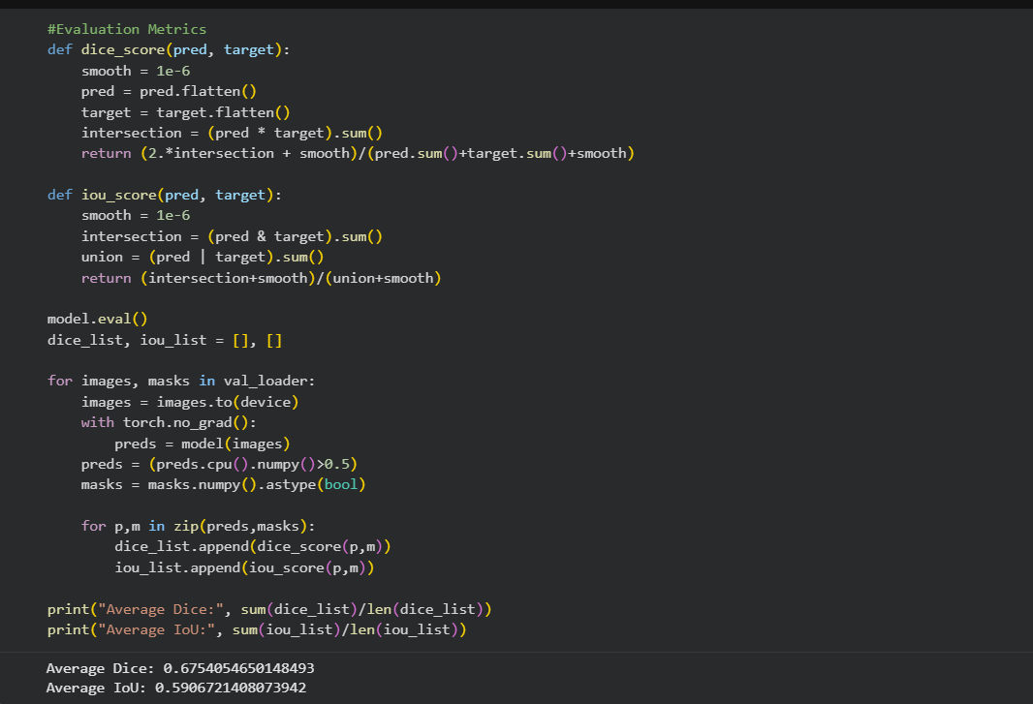
Fig 11

8. Model Evaluation

The performance of the proposed segmentation model was assessed using both quantitative and qualitative approaches. Pixel level comparison between the predicted masks and ground truth annotations was carried out on the validation set.
Four different evaluation criteria were taken into account: Dice coefficient, Intersection over Union (IoU), precision and confusion matrix analysis. The Dice coefficient is a measure of similarity between two segments, and it is very useful in the context of medical image segmentation. IoU is a measure of region agreement, and precision shows the proportion of predicted tumor pixels that are indeed tumor pixels.
The trained model performed very well in terms of the Dice coefficient and IoU showing a very good overlap between the predicted and annotated tumor regions. The precision value also confirmed that most of the predicted tumor pixels lie within the actual tumor regions. The confusion matrix also showed that the true positives were much higher and the false positives were mostly concentrated around the irregular boundaries of the tumor.
The visual check of the segmentation results indicates that the tumor areas have been localized correctly even in low contrast ultrasound images. Nonetheless some minute inaccuracies in boundary delineation have been noted in areas where speckle noise and shadowing are present. This is not surprising since ultrasound imaging inherently has noise patterns that correspond to tissue structures.
The results also indicate the effect of class imbalance. The tumor pixels are significantly fewer in number compared to the background pixels. Consequently minute errors in segmentation could have a disproportionately large effect on IoU metrics while the Dice metric remains more or less stable as evident from Fig 12, 13 and 14.
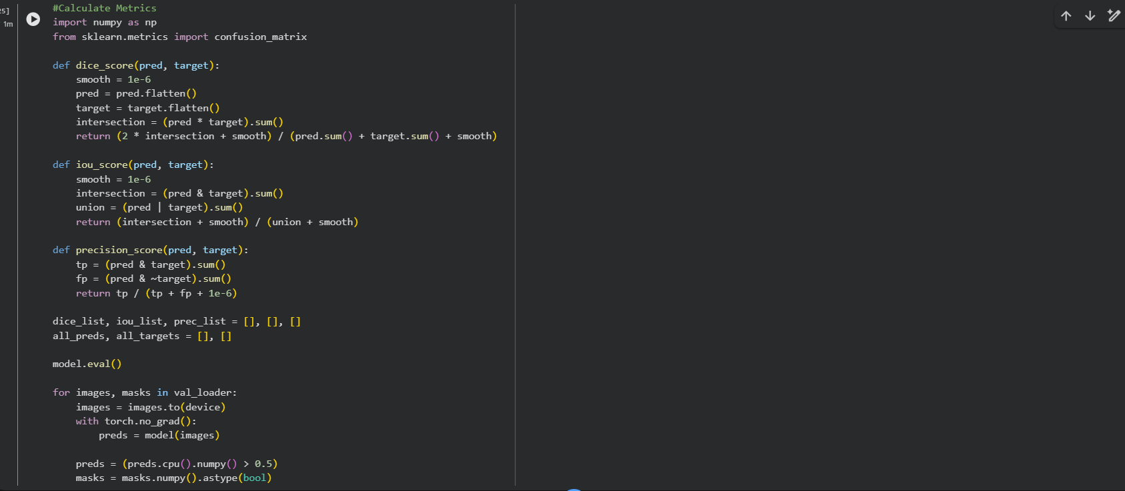
Fig 12
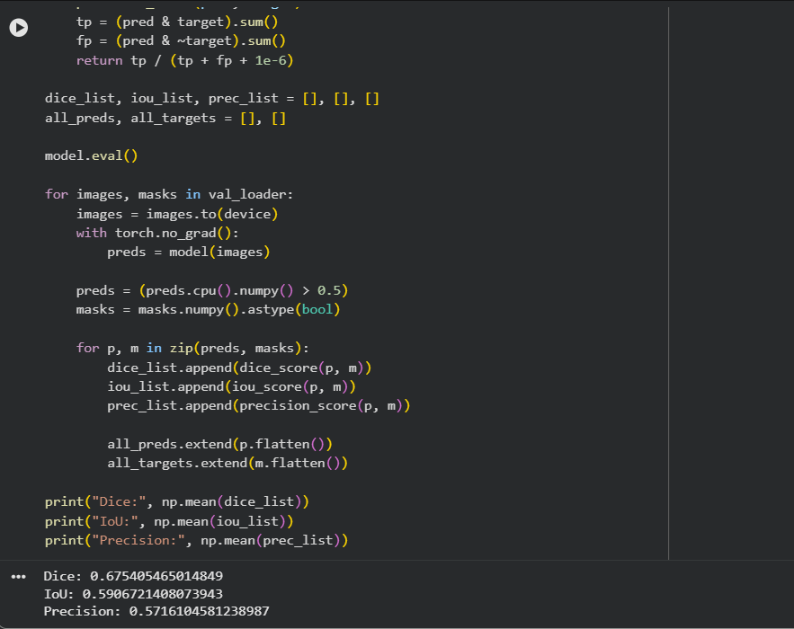
Fig 13
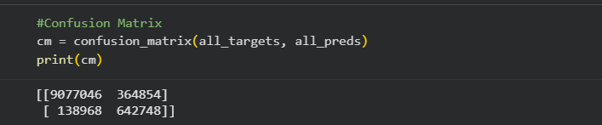
Fig 14

8.1 Comparison with State of the Art Models
As compared to more complex models like DeepLabV3 and nnU-Net , the U-Net model implemented in this study performed competitively with lower computational requirements. DeepLabV3 relies on atrous convolution for multi scale context information and generally has slightly better boundary accuracy but with higher computational complexity. nnU-Net is an adaptive model that adjusts its parameters according to the dataset and generally has the best possible accuracy but with high computational complexity in terms of training time and resources.
The implemented U-Net model on the other hand provides a good trade off between segmentation accuracy and computational complexity. The model performs well even on small medical datasets and can be trained on a lightweight setup like Google Colab as shown in Fig 15.
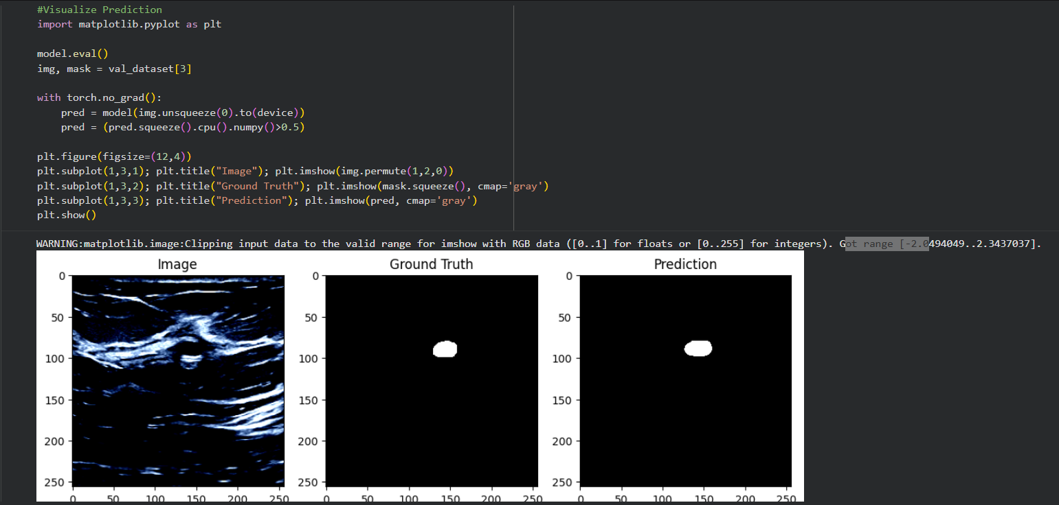
Fig15

9 .Conclusions

In this project a method for the automated segmentation of breast tumors in ultrasound images using deep learning was proposed. A pipeline for the structured preparation of the dataset was designed and a U-Net architecture with a ResNet34 encoder pretrained on ImageNet was implemented. The model was able to learn the pixel wise classification and generate accurate segmentation masks.
The performance metrics used in this project were able to provide a reliable indication of the potential of artificial intelligence in assisting with medical diagnoses. Automated segmentation can be a useful tool in assisting medical professionals with diagnoses.
Although promising results have been achieved there are still some limitations. The current dataset has limited diversity in terms of imaging devices and patient populations which may impact generalization to real-world applications. Additionally ultrasound noise and low contrast also bring uncertainty to the segmentation task around tumor boundaries. Moreover training deep learning models requires computational power that is not always accessible in real world applications.
Future studies may focus on training models on larger multi institutional datasets incorporating multi-modal imaging modalities such as MRI and CT and designing models for real time applications. Moreover, the proposed framework can be extended to other tasks related to tumor segmentation such as lesion classification disease diagnosis and object detection in radiological imaging.
In summary, this study has shown that deep learning based segmentation systems can contribute greatly to the improvement of computer assisted medical diagnostics and healthcare efficiency.

10. REFERENCES

Alom, M.Z., Yakopcic, C., Taha, T.M. and Asari, V.K., 2019. Recurrent residual convolutional neural network based on U-Net (R2U-Net) for medical image segmentation. Neural Networks, 109, pp.70 - 82.
Çiçek, Ö., Abdulkadir, A., Lienkamp, S.S., Brox, T. and Ronneberger, O., 2016. 3D U-Net: Learning dense volumetric segmentation from sparse annotation. Medical Image Computing and Computer-Assisted Intervention (MICCAI), pp.424 - 432.
Howard, J. and Gugger, S., 2020. Deep Learning for Coders with Fastai and PyTorch. Sebastopol: O’Reilly Media.
Isensee, F., Jaeger, P.F., Kohl, S.A., Petersen, J. and Maier-Hein, K.H., 2021. nnU-Net: a self configuring method for deep learning-based biomedical image segmentation. Nature Methods, 18(2), pp.203-211.
Litjens, G. et al., 2017. A survey on deep learning in medical image analysis. Medical Image Analysis, 42, pp.60-88.
Ronneberger, O., Fischer, P. and Brox, T., 2015. U-Net: Convolutional networks for biomedical image segmentation. Medical Image Computing and Computer Assisted Intervention (MICCAI), pp.234- 241.
Selvaraju, R.R. et al., 2017. Grad-CAM: Visual explanations from deep networks via gradient-based localization. IEEE International Conference on Computer Vision (ICCV).
Sudre, C.H. et al., 2017. Generalised Dice overlap as a deep learning loss function for highly unbalanced segmentations. Deep Learning in Medical Image Analysis (DLMIA), pp.240–248.
Al-Dhabyani, W., Gomaa, M., Khaled, H. and Fahmy, A., 2020. Dataset of breast ultrasound images. Data in Brief, 28, 104863.
Chen, L.C., Papandreou, G., Kokkinos, I., Murphy, K. and Yuille, A.L., 2018. DeepLab: Semantic image segmentation with deep convolutional nets, atrous convolution, and fully connected CRFs. IEEE Transactions on Pattern Analysis and Machine Intelligence, 40(4), pp.834-848.
Dice, L.R., 1945. Measures of the amount of ecologic association between species. Ecology, 26(3), pp.297-302.
Jaccard, P., 1912. The distribution of the flora in the alpine zone. New Phytologist, 11(2), pp.37-50.

11. BIBLIOGRAPHY

Al-Dhabyani, W., Gomaa, M., Khaled, H. and Fahmy, A., 2020. Dataset of breast ultrasound images. Data in Brief, 28, p.104863.
Alom, M.Z., Yakopcic, C., Taha, T.M. and Asari, V.K., 2019. Recurrent residual convolutional neural network based on U-Net (R2U-Net) for medical image segmentation. Neural Networks, 109, pp.70-82.
Chen, L.C., Papandreou, G., Kokkinos, I., Murphy, K. and Yuille, A.L., 2018. DeepLab: Semantic image segmentation with deep convolutional nets, atrous convolution, and fully connected CRFs. IEEE Transactions on Pattern Analysis and Machine Intelligence, 40(4), pp.834-848.
Çiçek, Ö., Abdulkadir, A., Lienkamp, S.S., Brox, T. and Ronneberger, O., 2016. 3D U-Net: Learning dense volumetric segmentation from sparse annotation. Medical Image Computing and Computer Assisted Intervention (MICCAI), pp.424-432.
Dice, L.R., 1945. Measures of the amount of ecologic association between species. Ecology, 26(3), pp.297–302.
Howard, J. and Gugger, S., 2020. Deep Learning for Coders with Fastai and PyTorch. Sebastopol: O’Reilly Media.
Isensee, F., Jaeger, P.F., Kohl, S.A., Petersen, J. and Maier Hein, K.H., 2021. nnU-Net: a self-configuring method for deep learning-based biomedical image segmentation. Nature Methods, 18(2), pp.203-211.
Jaccard, P., 1912. The distribution of the flora in the alpine zone. New Phytologist, 11(2), pp.37-50.
Litjens, G. et al., 2017. A survey on deep learning in medical image analysis. Medical Image Analysis, 42, pp.60-88.
Ronneberger, O., Fischer, P. and Brox, T., 2015. U-Net: Convolutional networks for biomedical image segmentation. Medical Image Computing and Computer Assisted Intervention (MICCAI), pp.234-241.
Sudre, C.H. et al., 2017. Generalised Dice overlap as a deep learning loss function for highly unbalanced segmentations. Deep Learning in Medical Image Analysis (DLMIA), pp.240-248.

12.APPENDIX

Computer Vision Google colab Link - Computer Vison Deep learning

